2023 Web Application Group Project Milestone 1: Research and Planning

**Overview:**

The goal in this group project is to design and develop a social web application which acts as a hub for student created clubs. The clubs will post on the application which allows them to make updates, promote themselves, and find new members while general users can join clubs and see their club’s updates and upcoming events. Information stored on the website is stored in a database system in SQL and the web application must use NodeJS, Express, Vue.JS and AJAX.

**Research:**

Since the desired application is a social web application, research for ideas can be taken from existing social media applications.

1. <https://www.facebook.com/>

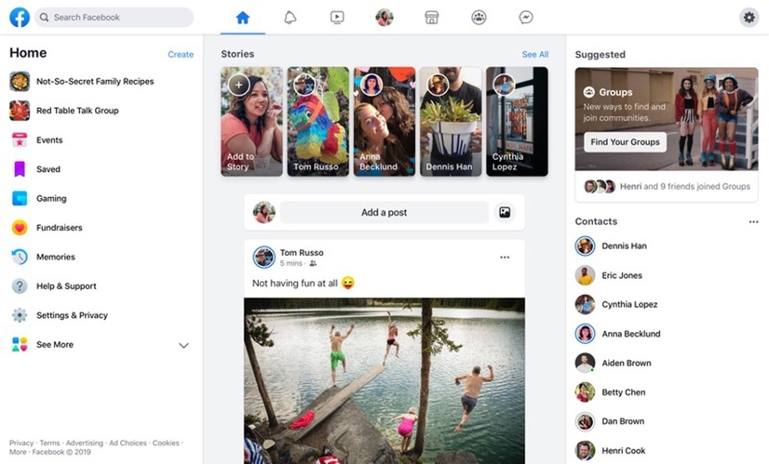

Facebook’s home page is split into thirds, with the centre and largest segment showing posts made by those whom the user follows or is friends with while the left segment contains is the home navigation bar and the right segment shows the user’s friends and contacts. Additionally, the top of the page shows a navigation bar which allows the user to move through different areas of Facebook such as Marketplace and Messenger.

Our webpage can take examples from Facebook’s homepage as its format allows the user to immediately get a glance of all possible options within the app by scanning the page in a F shaped pattern. Additionally, it’s main content which is updates and posts from people the user follows is shown front and center, but additional options such as settings, searching for content, and searching for friends are close by.

A feature our website could take from Facebook is the Events feature, which allows users to create private or public events and invite people, and people can respond their interest or RSVP to the event. The application could take after this by having club managers be able to create events and target them to either club members, or to the public and the event will show in everyone’s feed. Additionally, users can RSVP to the event. Facebook does not allow for free exploration without login and the user will usually be redirected to the login page.

Facebook’s style is sleek and only uses blue, white and blue. However there are also other colours used such as the different post buttons using red, yellow, and green which correspond to different post types. However, I believe that the navigation bar is far apart from the posts which causes the user to move more to navigate the page, and the fonts for some of the texts are small, making it harder to read especially on small screens.

1. <https://twitter.com/home>

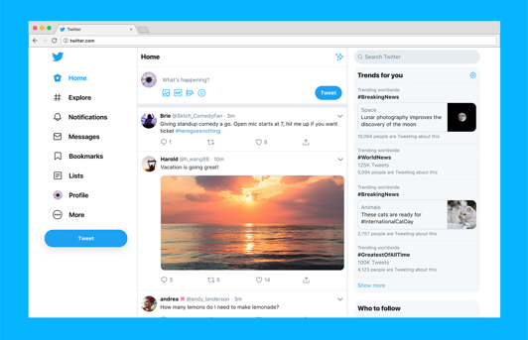

The twitter home page is similar to Facebook’s home page, albeit it has a sleeker and larger look and its elements are closer together, reducing kinematic load when navigating. Like Facebook, the homepage is divided into three with the left and center panels being a navigation panel and the post content respectively. However, the rightmost panel is a list of suggestions such as topics and who to follow. The app version of Twitter only fits the main post feed on the screen, however swiping right will show the navigation bar on the left side of the desktop home screen.

For the desktop version, the left/navigation bar side is sized to a width of 259px with a border of 8px (side only), the middle/content part is sized to a width of 566px (height depends on scrolling) with a 16px border (side only), and the right/search side is sized to a width of 350 and a height of 899 with 12px padding on the top and 64px padding on the bottom. If the screen is reduced, then the navigation bar shortens first before the right side disappears. After that, further reduction causes the post content to reduce in size.

Additionally, the mobile version always has another navigation bar on the bottom of the screen for searching, notifications and messages. Twitter allows for somewhat free exploration without login. Users can still look through posts and accounts and search, but they will also be constantly prompted to login or sign up with a closable popup.

Twitter’s style scheme can also be used as a basis for our web application’s style, as its font and symbols are sleek and simplistic and the website uses only three colours: blue, black and white.

1. <https://youx.org.au/interests/clubs/>

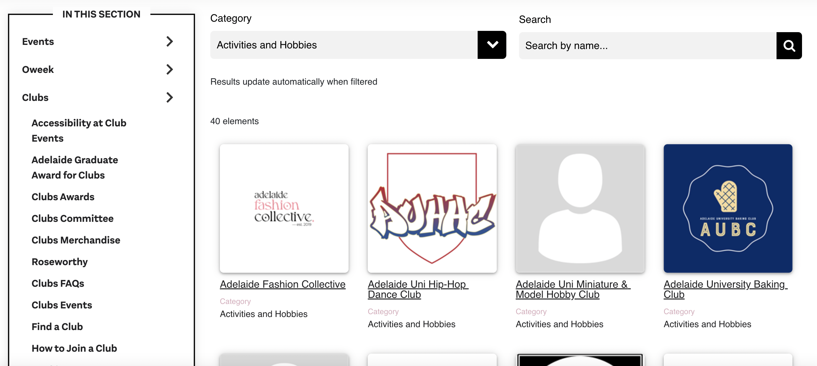

The YouX clubs website provides a possible interface for searching clubs up. However, since YouX is not a social platform, the user cannot join clubs through this website. The application could take after the website by having a section where the user can search for clubs to join, and they can filter out clubs by categories. When a club icon is clicked, it shows the club’s profile. YouX has a minimalistic style using only black and white for its elements.

**Design:**

Two basic design drafts were sketched out for review.

Draft 1 – Features

The first design is based off Facebook’s web design. The sign-up screen allows the user to input their name, date of birth, email, phone, gender, and password, and once the user signs up or logs in, they will be taken to the home screen where they are allowed to join clubs and see updates. The login page will prompt the user the enter in their username/email and password and can also prompt the user to sign-up using other media, reset their password, and link the user to the sign-up page.

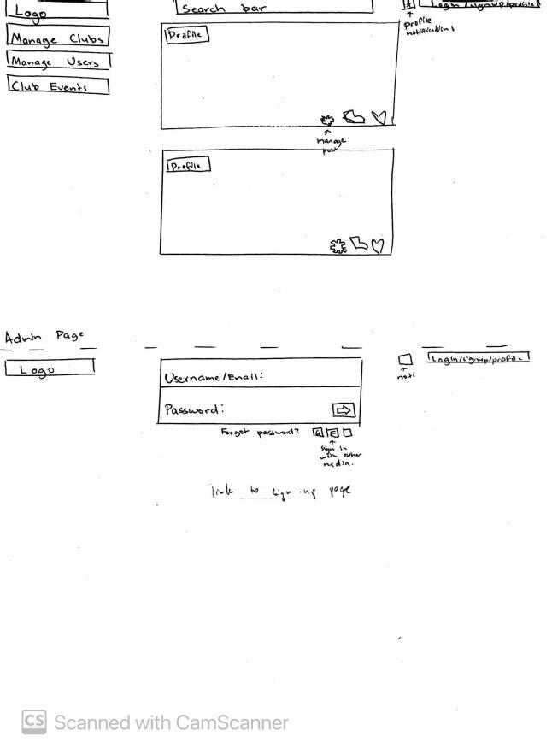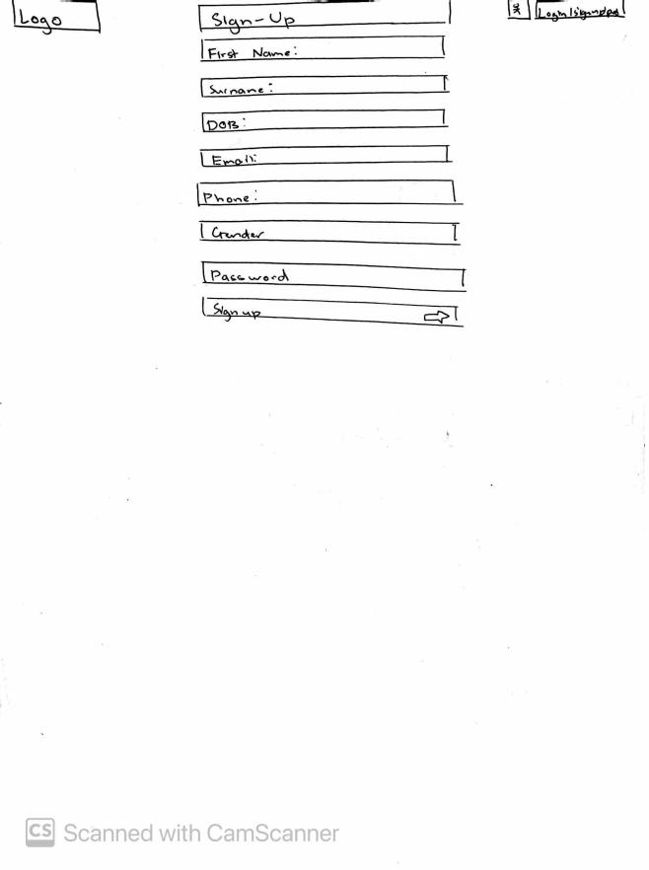

The pages in the first basic design contain a top navigation bar and the rest of the page is split into three sections, with the left side showing a navigation bar for the specific page and the right side showing the user’s notifications for updates and events. In the middle section for the homepage, users can see posts from clubs that they follow and can like and share the posts. Additionally, there is a search bar on the top of the screen so that the user can search posts from specific clubs, and a profile button is placed next to the login button so that users can view their profile. Club managers have an additional section in their homepages which allows them to post as their club.

System admins have access to an administration page where they can search up and manage users and clubs. There is a different page for managing clubs and users as seen on the navigation bar on the left and clicking on any of them will display a search bar where the admin can look up what they desire. They can then manage users and clubs by clicking on their profile.

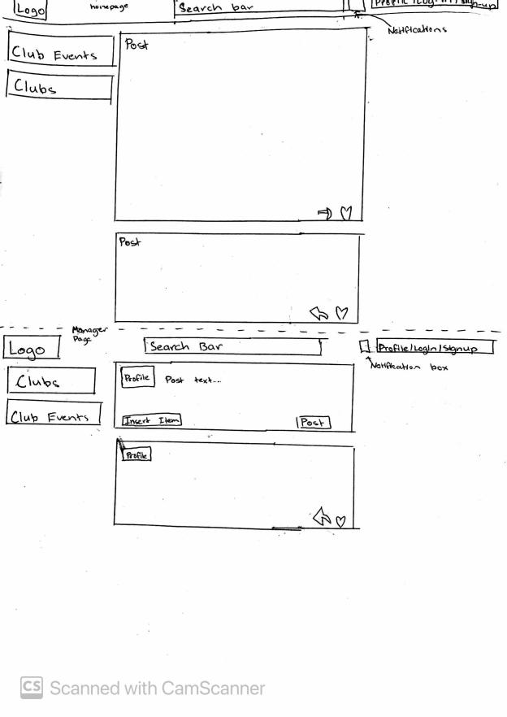

The profile page shows a large form of details which the user can update. The user can also change their profile picture by uploading a image file. The clubs page lists the clubs which the user searches up on the left side navigational bar and in the middle, the site shows the club’s profile which includes an image of the club banner, a div containing the club’s name, member count and a basic club description as well as a join button, and below this div will show the club’s posts and updates. The club information can be modified within this page by a club manager or admin.

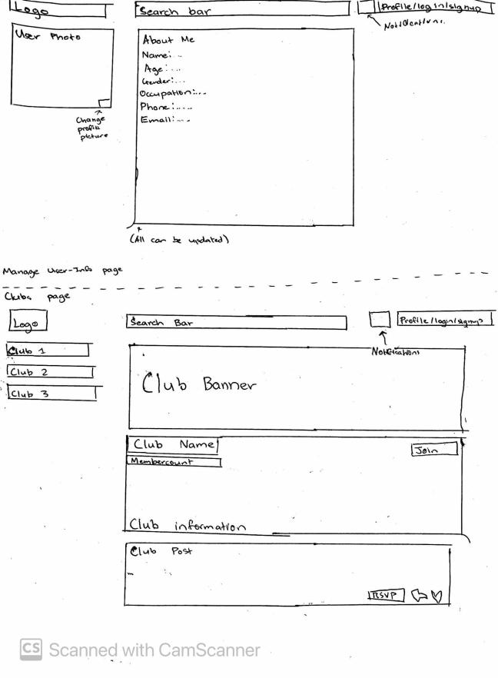



When the web application is reduced, the side navigation bar should reduce first and eventually become a small square shaped icon before the size of the middle content div reduces in size. The middle div should never disappear. The mobile version of this website mainly has the same format but the navigation bar is reduced to small squares.

Draft 2 – Features

The second design is based off Twitter’s web design and was drawn with the assumption that the screen size would be 1300px wide, with the elements being proportional to the screen size. All pages will have the same layout, where the left side is a navigation bar for the different sections of the website and the top of the page contains the app logo, the page name, and the login/logout button. The left navigation panel is 400px wide and each button on the panel is 300x50px. The middle section is about 600px wide and changes depending on what page the user is currently on, and the right section is about 300px wide. The navigation panel contains links to general pages such as the user’s clubs, events, and profile. However, admins will also have an additional button on the navigation panel which takes them to an administration page where they can manager users and clubs.

The middle div on the home screen will show the updates from the user’s clubs and the user can scroll down to see more posts. Managers however will have an extra section at the top of this page where they can post updates for the club which they manage. The right div for the home screen contains a search and filter system where users can type in a specific club and get only their posts on their screen. When the screen size is reduced, the notifications bar should reduce and then disappear or become a toggleable element which can appear or disappear if a button is pressed. After the notification bar disappears, the navigation panel will reduce in size until each button becomes a small square showing its icon. After that, only the small navigation panel and the middle div is shown.

Each user has a profile page where they can edit their details as well as their profile image. The profiles page also contains the list of clubs which the user has joined and if the user is looking at their own profile, they can also be directed to the ‘My Clubs’ page.

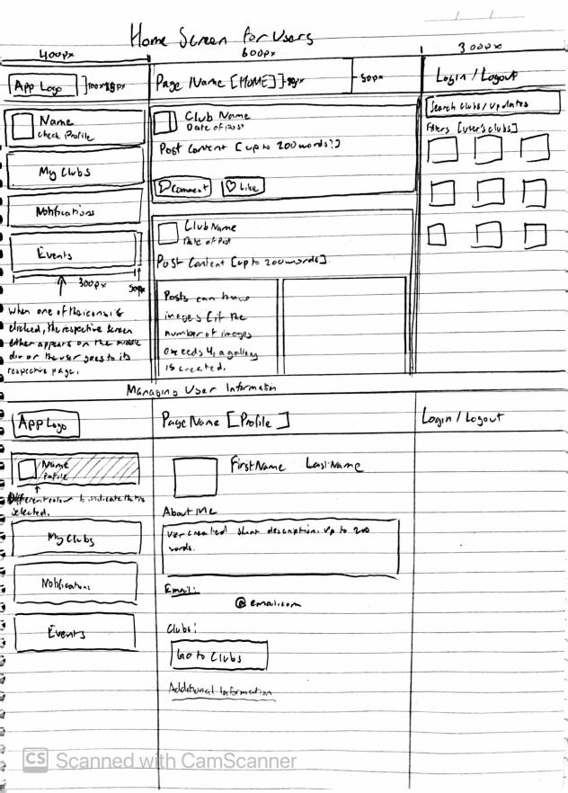



The ‘My Clubs’ screen shows the users clubs represented by a square icon and each icon has a button below which allows the user to join or leave the club. The user can also search for clubs to join using this screen by typing on the search bar or filtering out categories. This page for club managers is mainly the same, however there is a third section at the top which is structured similarly to the ‘Your Clubs’ segment which shows the clubs which the user is currently managing. Clicking on any of the club icons takes the user to the club’s specific page, which is structed similarly to the profile page, containing an icon, name and description at the top. The main differences between the club page and the profile page however is that there is an extra button at the top which users can click to join or leave the club, and below the club description is the club’s updates, structured similarly to a Twitter profile.

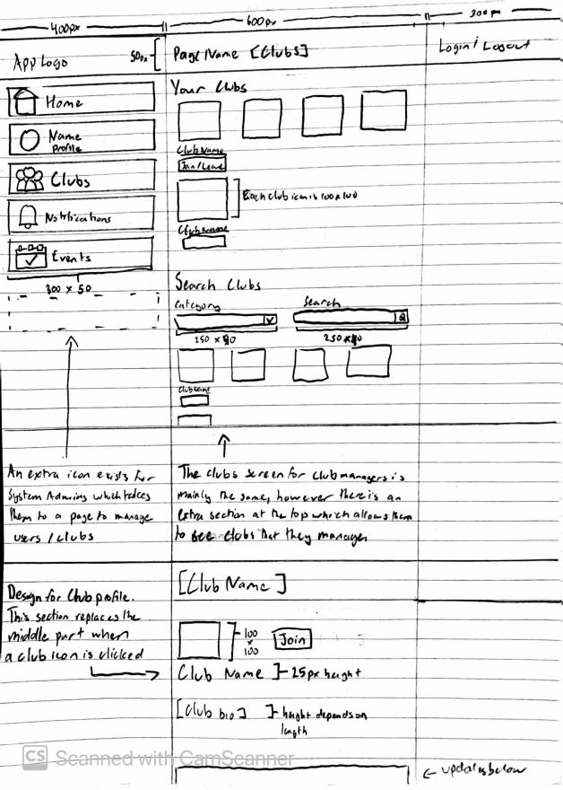

The events page has a navigation bar at the top where the user can filter between all events (users can look at public events that are not from their club), events from the user’s clubs, and events that the user has RSVP’d to. After filtering, the user is shown a list of cards showing the event name, the hosting club, location and date and the user can express their interest using the button in the card. Clicking on the card takes the user to the event’s page, which like the profile pages for users and clubs shows details of the event and the user can RSVP to the event. When club managers access the event page for clubs they manage, they can edit the details of the event, set it to a private or public event, and see who has RSVP’d to the event.

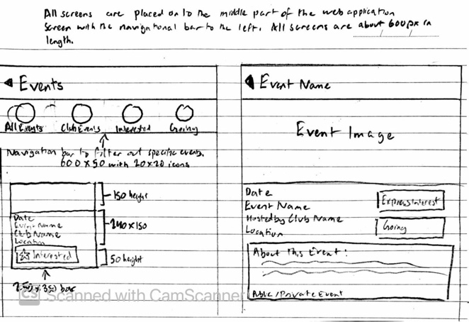

Review

Both designs have layouts which allow the user to scan quickly through each page without losing any important information displayed and use a homepage as a gateway to other pages through a navigation panel. Additionally, both designs have layouts which attempt to reduce kinematic load by having larger elements which are close to each other. Accessibility is also present even before deciding on visual elements such as icons, colours, and fonts, with the second design using large text and icons and both designs having readable and predictable redirects to other pages and elements within the web application. However, both designs also present some noticeable flaws in its design:

* The first design has an inconsistent navigation panel, with elements within it changing for each page, which means that if a person is on a specific page and wishes to access a different page, they may have to sift through unrelated pages, increasing cognitive and kinematic load.
* The signup page of the first design prompts the user to add in unnecessary information such as a date of birth, phone number, and gender. These should be changed to be optional profile settings which can be added after signing up.
* The proportions of the content on each page in the first design is inconsistent (e.g. the content in the clubs page is longer than the other pages).
* Elements in the first design tend are somewhat distant from each other causing more kinematic load to be used.
* The right side of the second design is mainly empty except for the home screen, making the page look empty and unfinished. The search system for the home screen should be located on the middle div so that there is less kinematic load whenever the user wants to search for content.
* There should be a ‘change info’ button which appears only for users within their own profile page or club managers within their own club page.
* The information presented in the event cards and page within the second design are all the same size, with causes the information to appear together as a blob. Different sizes should be assigned to each piece of information depending on its importance.

Final Design

The final design mainly takes after the second design such as its proportions, its layout where only the middle div changes, and pages having toggleable elements depending on the type of user, but the design also has elements taken from the first design to alleviate the design weaknesses listed above.

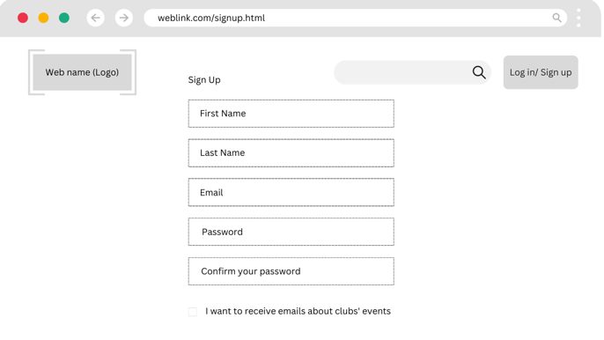

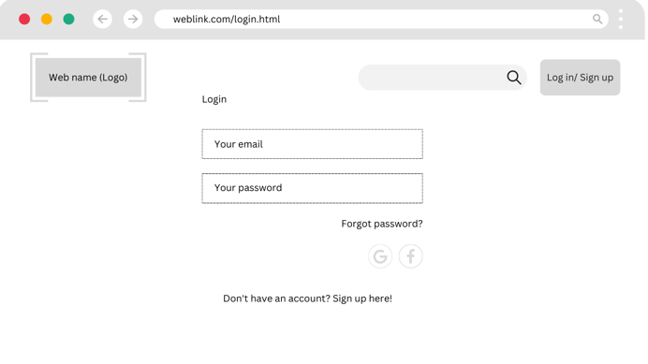

The main difference between the drafted design and the final design mock up is that the top section contains a search bar that will allow the user to search up posts and pages, and this page will be present throughout the website’s pages. Additionally, the right div now contains the notifications section which will show important information to the user such as club updates and upcoming events. We believe that these changes will reduce the kinematic load of the website by having elements closer to each other as well as reducing cognitive load as more information will be initially present to the user.

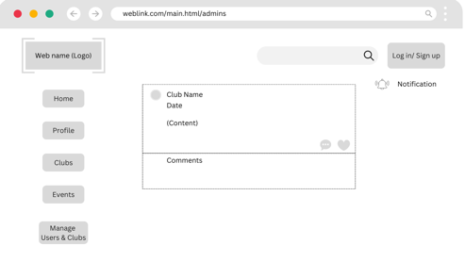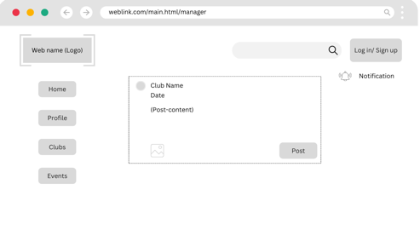

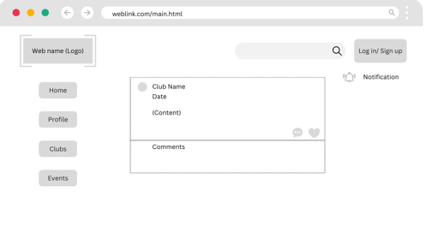

We wanted to go with a minimalistic colour scheme similar to websites such as Twitter and Discord, where only colour was used predominantly in elements. With this in mind, different colours were proposed.

* Bright colours such as light green and white were proposed, however these ended up being rejected as it may appear jarring. Additionally, green is a common colour that is difficult to see with colourblind people. Brown was also considered however a navy blue ended up being the predominant colour of our website as it would match the university’s colours. However, the logo on the top left would be a light brown in order to make it more recognisable.

**Database Schema:**

Based on the included elements within the design, a database schema for the application was created. The users table should include details which were filled in the signup form such as the name, email, and password. Users also have two Booleans for if they are an admin or a club manager, which will give permissions for different elements such as club management and the administration page. The required actions for users which are responding to posts, attending events, and joining clubs are present as separate tables which use the user id as a foreign key to check which user has access to which club’s posts as well as what would show up on the user’s notifications. Each membership is connected to a specific club as well, using its id as a foreign key, and the membership also has an assigned role used as an id (0 for managers, 1 for general members). Events are connected to a club through a foreign key and its elements such as description, name, time, location, and publicity will be present in the specific event page, event_attendance is where users can join events, using the event_id and user_id as foreign keys and the rsvp_status is used as an id (0 for interested, 1 for attending).

